HARMON.SAV is an SPSS data set which contains monthly reading of the following variables:

Y = Monthly Sales
X1 = Discount 1
X2 = Discount 2
X3 = Discount 3
X4 = Discount 4
X5 = Discount 5
X6 = Discount 6

The assumption is that the more discounts the companies applies vis-à-vis its customers, the higher the monthly returns. Therefore, our duty today (as Quantitative Analysts) is to test this assumption.

To run a Regression analysis, the consensus it to test for correlation between Y and the Xs. It is a pre-requisite to have a strong correlation between variables before running a Regression Analysis.
STEP1: PREREQUISITES
Test of correlation:
H0: correlation between variables ( Y and Xs) = 0 (is nil)
H1: correlation between variables ( Y and Xs) ≠ 0
The correlation test is a two-tailed test (because H0: Corr = 0 and H1: Corr ≠ 0)
Decision rule: Reject H0 if the significance of the correlation test is less than 5% (0.05)
Table 6.1 Correlations
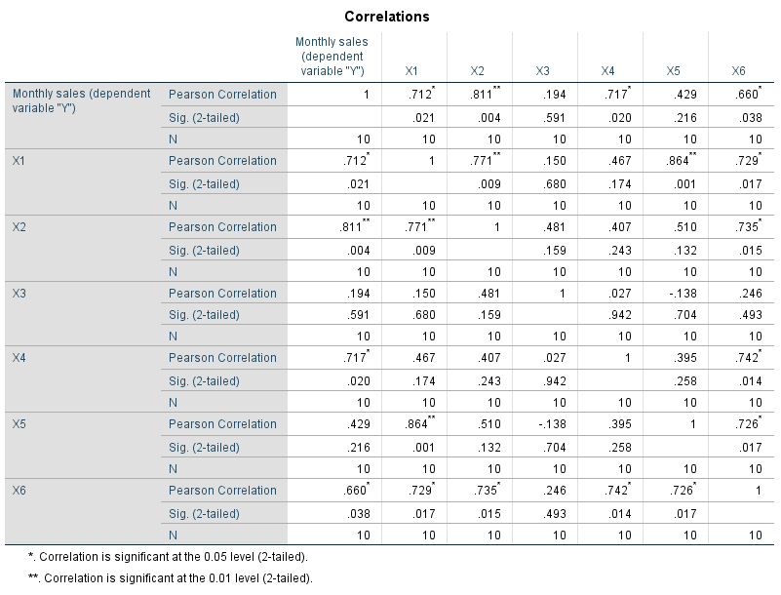
According to Table 6.1, the monthly are correlated with all discounts but three and five. The next step is to run a regression analysis using the stepwise method.

STEP2: PROCESS
Stepwise Regression identifies the explanatory variables that have a significant impact on the Y variable. As part of our analysis, we are supposed to examine the residuals that are generated following the regression modelling exercise.
Unstandardized residuals are simply the difference between the real values (Y) and the forecast values ($\hat{Y}$). In other terms Y - $\hat{Y}$ = errors = unstandardized residuals
Therefore, when we talk about Standardized residuals, this means that the latter were approached by the Normal distribution.

Y ($/£ values) | $\hat{Y}$ (values) | Errors (USTD. Residuals) | (xi – mean) | (xi – mean)^2 | Errors (STD)
1.29 | 1.28 | = 0.01 | 0.01 - 0.02 | (-0.01)^2 = 0.0001
1.30 | 1.25 | = 0.05 | 0.05 - 0.02 | (0.03)^2=  0.0009
1.31 | 1.30 | = 0.01 | 0.01 - 0.02 | (-0.01)^2 = 0.0001
1.33 | 1.32 | = 0.01 | 0.01 - 0.02 | (-0.01)^2 = 0.0001

Mean of residuals = (0.01+0.05+0.01+0.01)/4 = 0.02
Standard deviation of the residuals = sqrt [Sum(xi – mean)^2/n-1 ]
= Sqrt { (0.0001+0.0009+0.0001+0.0001)/3}
Standard deviation = 0.02
To generate the standard residuals, all we have to do is subtract each USTD residuals from the mean and divide the outcome by the standard deviation. The outcome of this process enables you to examine whether any of residuals has a standard value of greater than 2 or less than -2. In the case whereby STD residuals are between 2 and -2, you can safely conclude that the residuals are normally distributed.

Table 6.2 Explanatory variables from Stepwise Regression
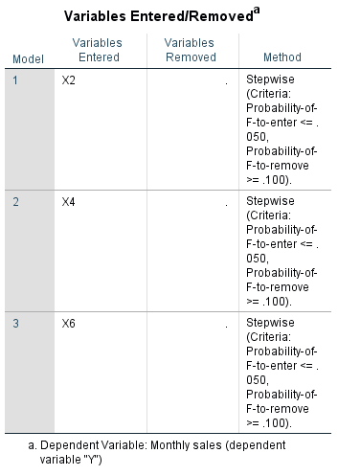

6.3 Coefficient of correlation R / Coefficient determination R^2
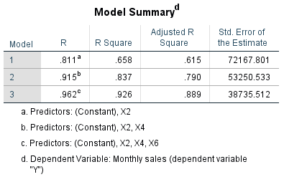
According to Table 6.3, the correlation (R) between Y and X2, X4 and X6 is strong (R= 0.962)
The coefficient of determination (R-square) indicated that 92.6% of changes in Y (Monsales) are due to a linear relationship with Discount 2, 4 and 6. The rest (7.4%) is due to extraneous factors or other variables not included in this regression model.

6.4 Regression Coefficients

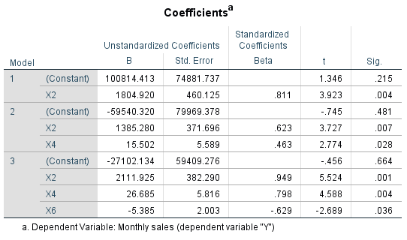

According to Table 6.4, the regression equation can be written as:
Y (monsales) = -27102.134 + 2111.925*X2 + 26.685*X4 – 5.385*X6
If no discounts are applied, monsales = -27102.134
For each one unit increase in discount 2 (X2), monsales will go up by 2111
For each one unit increase in discount 4 (X4), monsales will go up by 26
For each one unit increase in discount 6 (X6), monsales will decrease by 5

When the Xs (explanatory variable) used in the Regression Analysis are correlated, this leads to a problem called MULTICOLLINEARITY.
- Increase in R-square is spurious (artificial)
- Gradients are wrong in size
- Gradient are wrong in sign
- The test of the gradient (Beta = 0) is unreliable
STEP 3 DIAGNOSTIC
Figure 6.1 Normality Plot (Residuals)
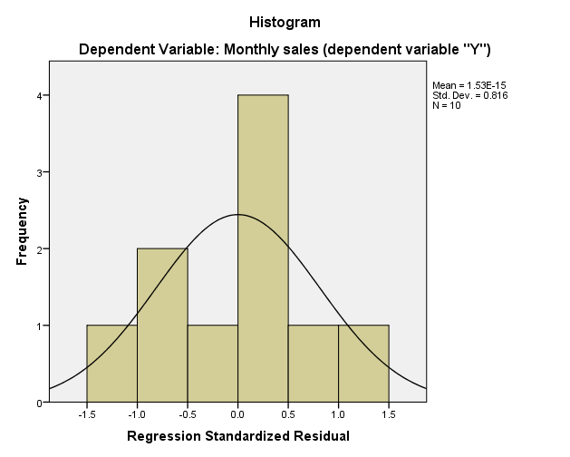
According to Figure 6.1, residuals are normally distributed.

Figure 6.2 Autocorrelation / STD residuals overtime
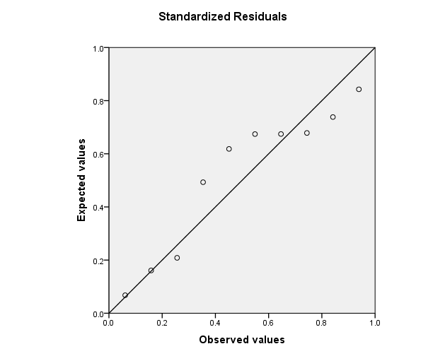
According to Figure 6.2, there seems to be evidence of autocorrelation of residuals.
Figure 6.3 Residuals HOMOSCEDASTICITY
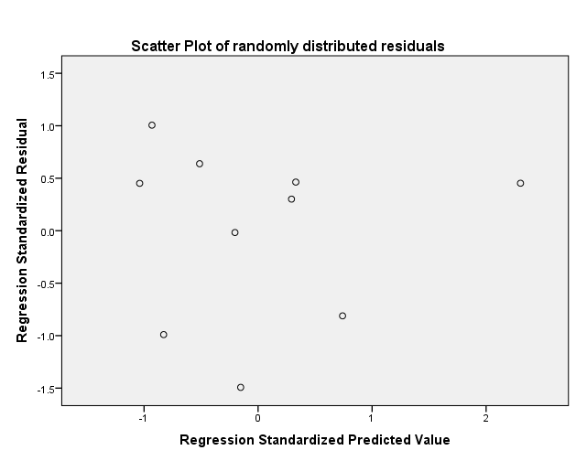
Homoscedasticity is the constant variance overtime of the residuals. According to Figure 6.3, the residuals seem to be heteroscedastic. In other terms, the variance of the residuals is not constant overtime.

As a conclusion, it is very important the stress that diagnostic on the regression residuals should be conducted. A healthy regression equation/model, needs to have its resdiuals:
- Normally distributed
- Not-Autocorrelated
- HOMOSCEDASTIC

Failure to achieve any of the above, threatens the originality of forecasts generated using the above regression models.

Figure 6.4 monthly sales and predicted sales
